1 to 4 – database and table created & given Operations are performed

5) **Develop queries to retrieve event information, generate attendee lists, and calculate event**

**attendance statistics**

a) **Retrieve event information**

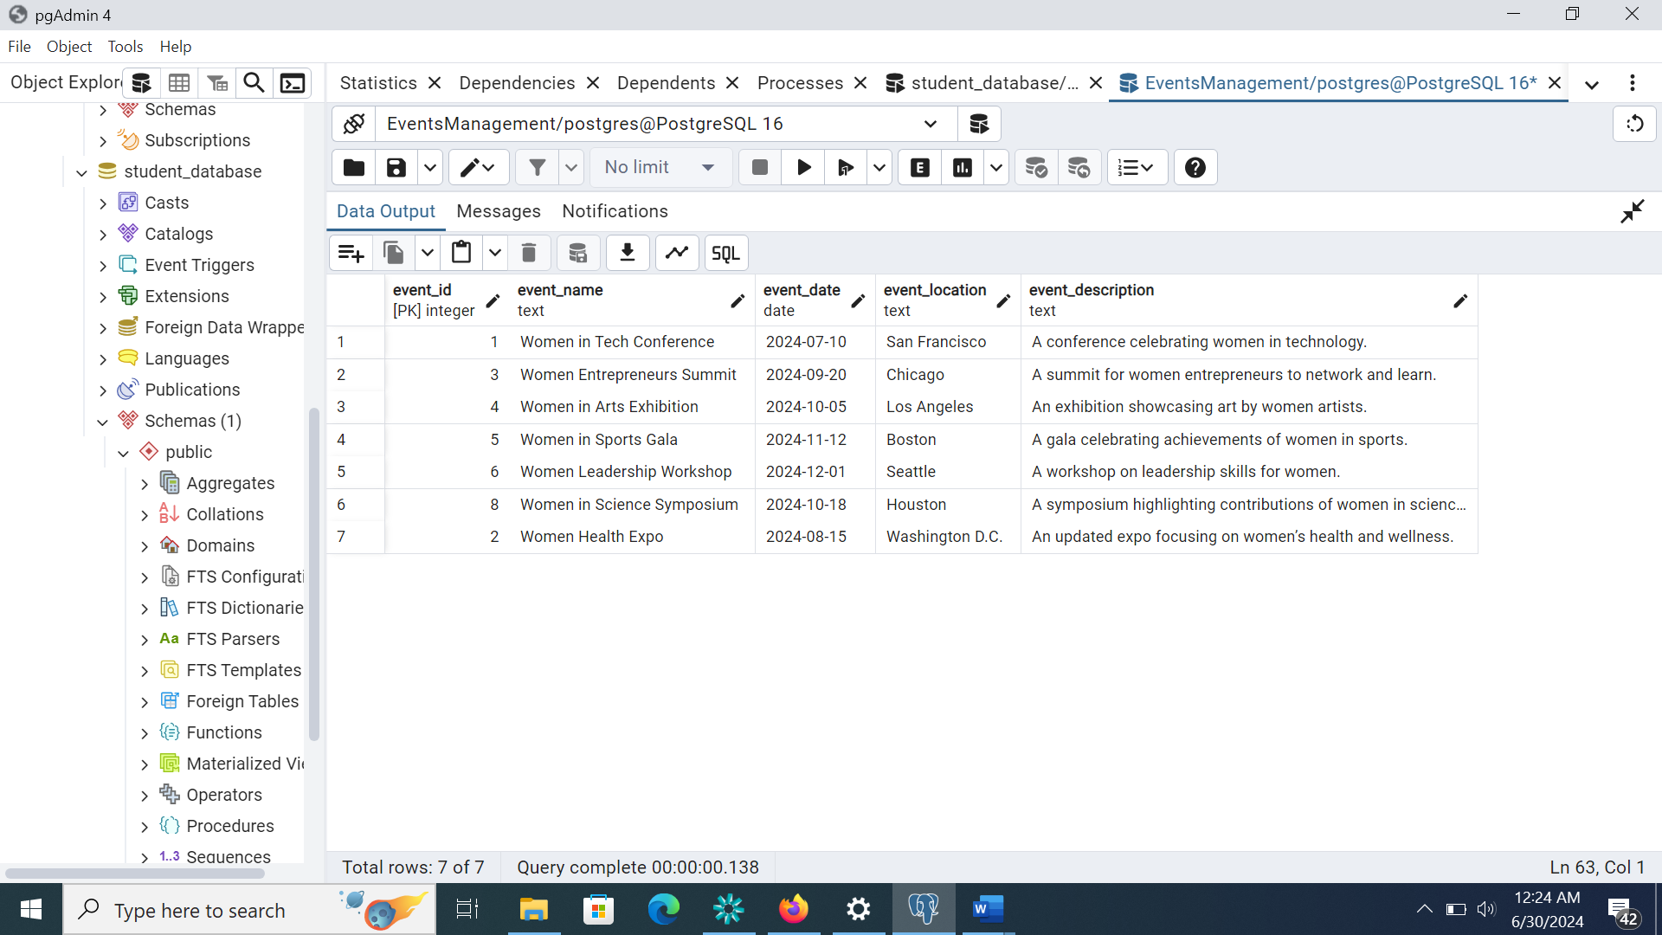

For a Specific Event

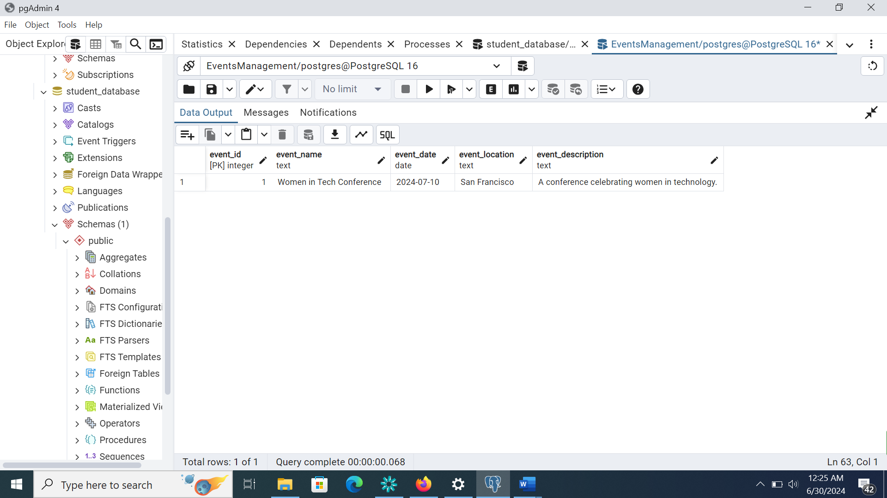

b) **Generate attendee lists for a specific event**

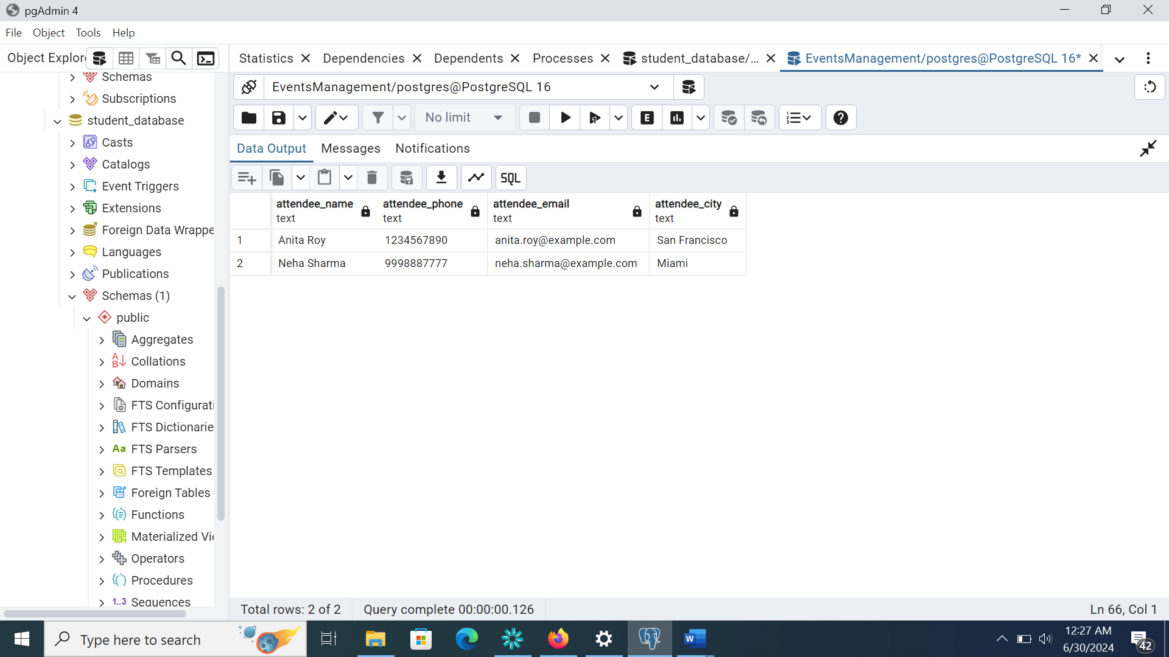

**For all events**

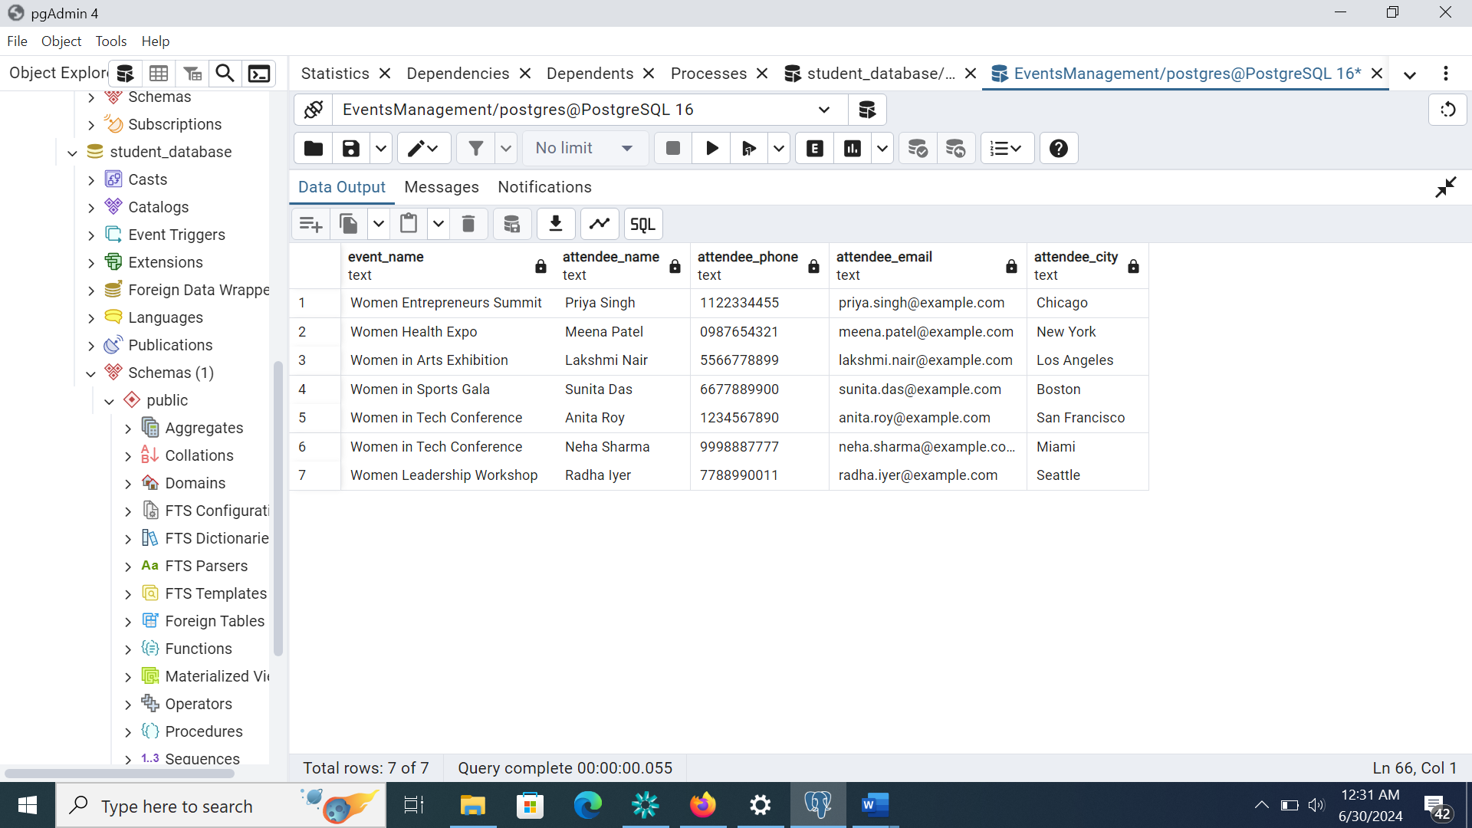

**c) Calculate the Total Number of Attendees for Each Event**

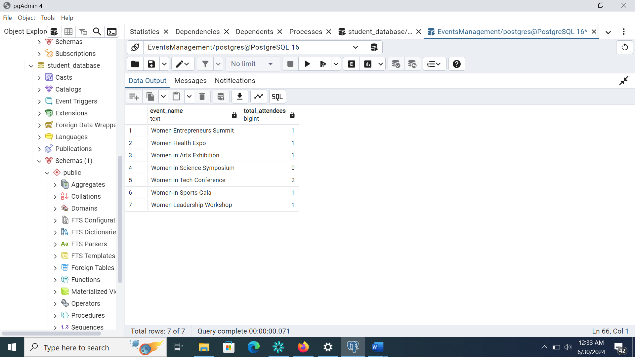

**d) Calculate the Total Registration Amount Collected for Each Event**

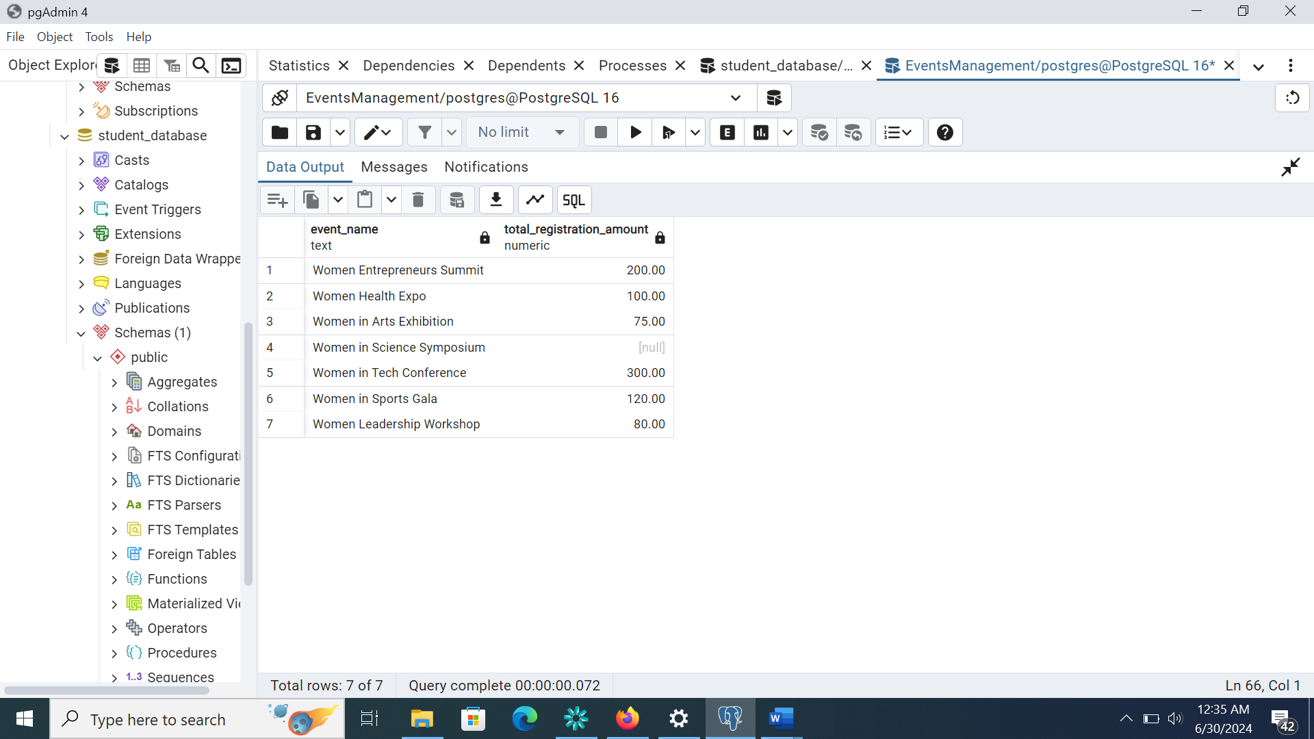

**e) Calculate the Maximum and Minimum Registration Amount Collected for Each Event**

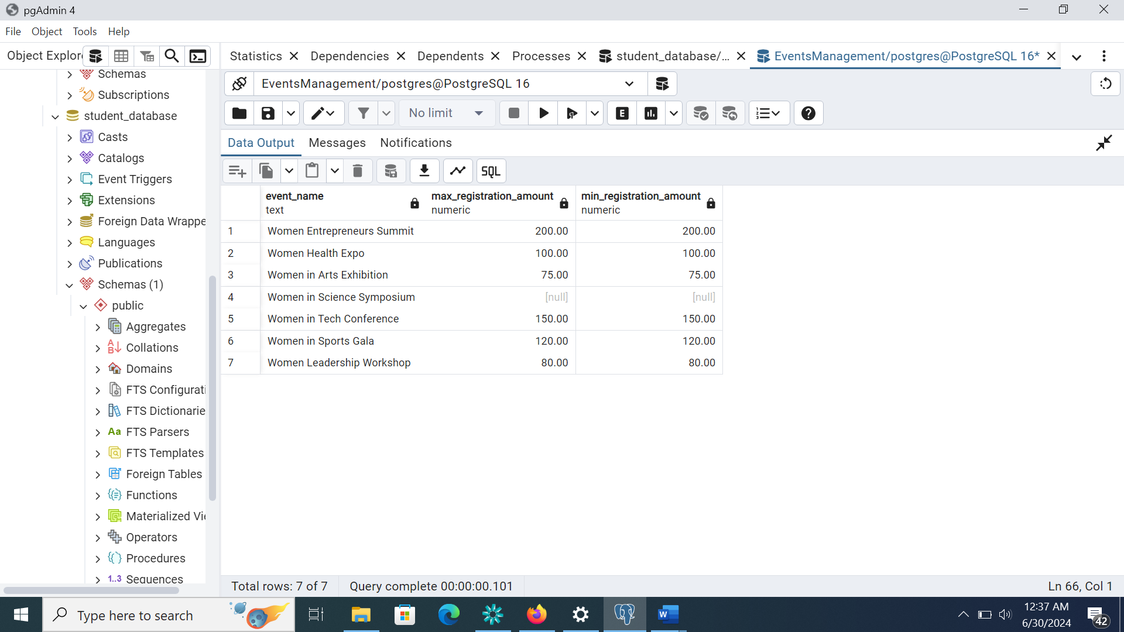

**f) List Events and Their Corresponding Attendee Count Grouped by Event Location**

